**Smart parking using machine learning algorithm**



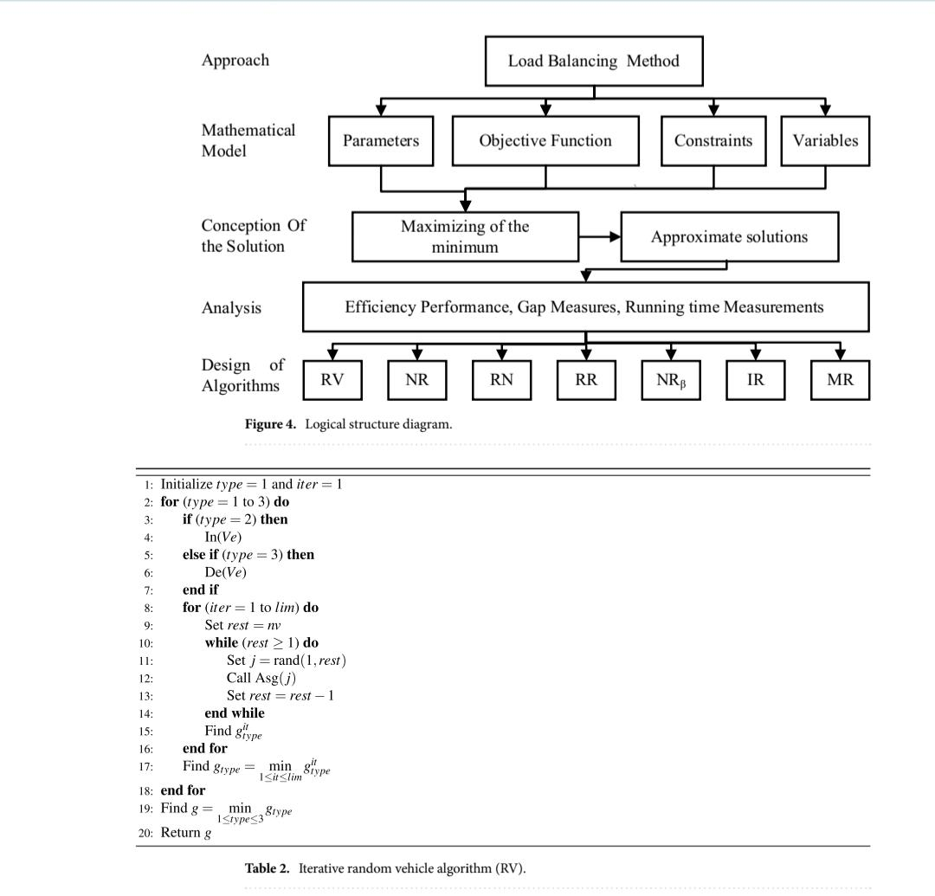**Iterative random vehicle algorithm (RV).** Randomization method is utilized to develop this algorithms As follows. First, classify the vehicles into three types. Te frst type, vehicle is chosen to be scheduled based on Vehicle index. Te next type is the scheduling of vehicles based on the non-decreasing order of the count of People in the vehicle. Te third type is the vehicle scheduling based on the decreasing order of the people count For each vehicle. For a certain type, choose a vehicle randomly from the set of given vehicles. Afer that, allocate The selected vehicle to the parking space that has the minimum total number of people, then repeat until fnishing all vehicles. Tis process is being repeated for many times. Terefore, for each type, execute the selection of Vehicles for lim times.In this context, the function rand(a, b) is responsible of deriving integers in the range a and b, while Asg(j) Is the function that assigns the vehicle j to the parking that has the minimum number of people. Let In() be the Function that sorts the given vehicles in an increasing order based on the number of people inside it. While, De()

**M‑vehicles with NI and random choice algorithm (NR).** Tis algorithm works as follows, schedule Part of the vehicles using the NI algorithm, then the remaining vehicles are scheduled by applying the random Choice of any of the remaining vehicles. Te frst chosen part is prepared based on a multiplication by the number of parking spaces, which is called the multiplier and is denoted by M. To illustrate, apply the NI algorithm For the frst 2 × np vehicles to be scheduled, the rest of the vehicles will be chosen randomly and will be allocated To the parking space that has the minimum number of people. For this case, the multiplier M is equal to 2. Iterate this algorithm for lim times. Afer that increment the multiplier M to 3 and so on until M × np < 50 and M × np < nv. Tis algorithm is given the name NR and Table 3 describes the related execution steps

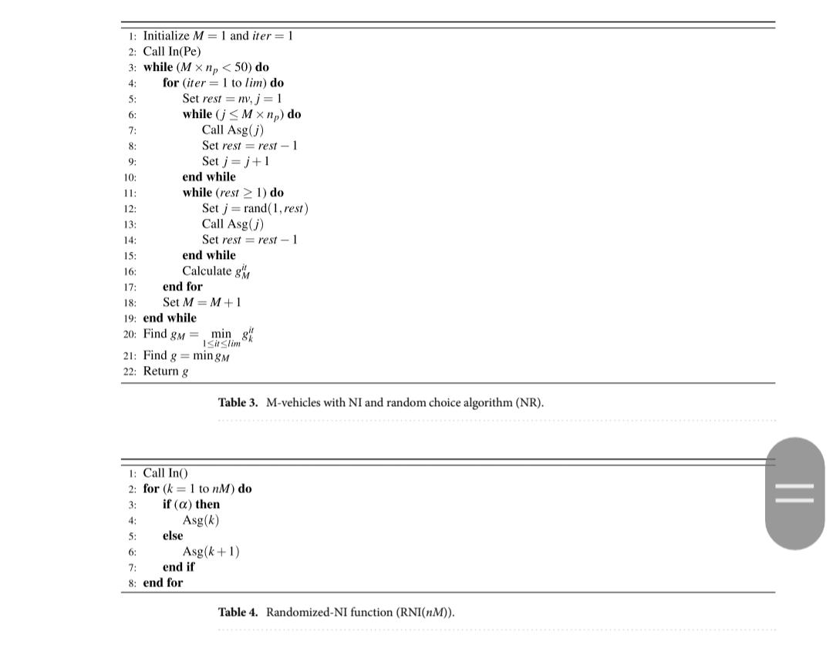**M‑vehicles with randomized‑NI and NI algorithm (RN)**. Tis algorithm works as follows, schedule Part of the vehicles using the randomized-NI algorithm, then the remaining vehicles are scheduled by applying the NI algorithm. Te frst chosen part is performed based on a multiplication by the number of parking Spaces, which is called the multiplier and is denoted by M. Te same iteration which is based on the multiplier M Adopted for NR will be utilized in this algorithm. Tis algorithm will be denoted by RN.In the randomized-NI procedure, the randomization is achieved by selecting a probability α to choose vehicle with the largest count of people and with 1 – α for the next vehicle with the largest number of people . Te Algorithm given in Table 4 describes the instructions of the randomized-NI procedure RNI(.). In this algorithm M × np (the input of the procedure) is the set of vehicles that will be set by the multiplier M described in NR.Next, the instructions that elaborate RN as detailed in the algorithm illustrated in Table 5 is given.M‑vehicles with randomized‑NI and random vehicle algorithm (RR). Tis algorithm works as follows, schedule part of the vehicles using the randomized-NI algorithm as described in the “M-vehicles with Randomized-NI and NI algorithm (RN)” section, then schedule the remaining vehicles by applying the random Choice of any of the remaining vehicles. Te same iteration which is based on the multiplier M adopted for NR Will be used in this algorithm. Tis algorithm is denoted by RR.Part of vehicles with NI and random vehicle algorithm (NRβ). Tis algorithm works as follows, Schedule part of the vehicles using the NI algorithm, then schedule the remaining vehicles by applying the random choice of any of the remaining vehicles. Tis algorithm will introduce the percentage that will be used to Divide the set of given vehicles. First, defne β to be the probability that will be used to apply the division. 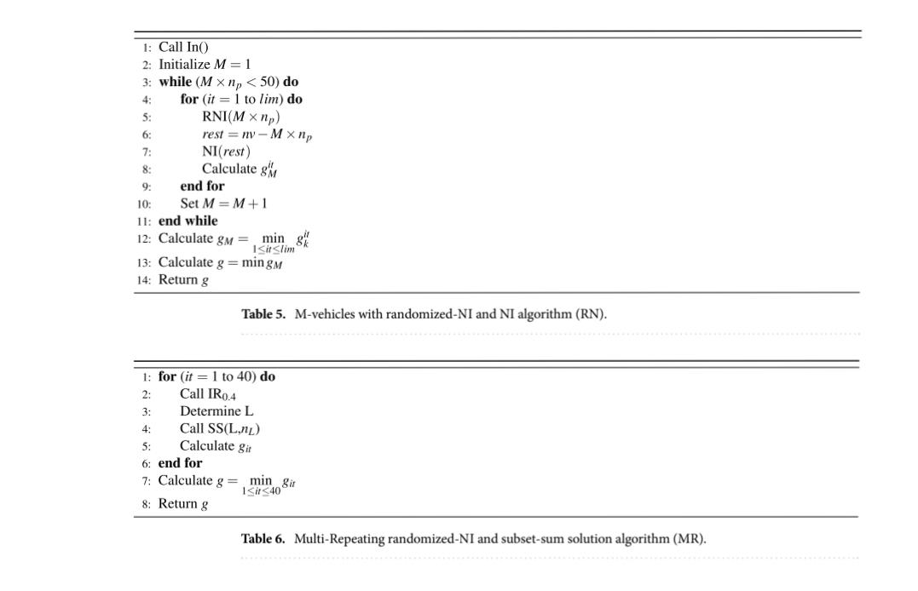Ten, Afer applying this division, two subsets S1 and S2, will be generated.

